Project Design Phase
Problem – Solution Fit
Date | 9 September 2026
Student Name | Yuvasri Malla
Project Name | Automated Licensed Software Installation Request Management
Maximum Marks | 2 Marks

Problem–Solution Fit
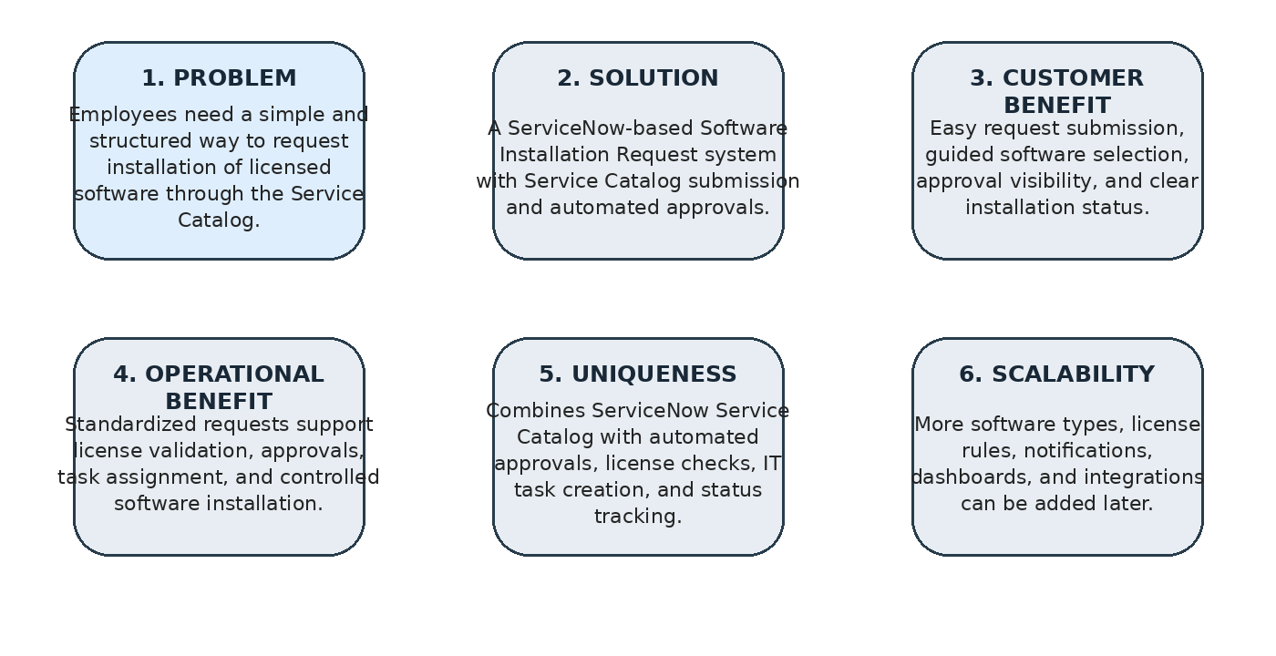
Figure 1: Problem–solution fit canvas for the Automated Licensed Software Installation Request Management.

Parameter | Project Fit
Problem | Employees need a simple and structured way to request installation of licensed software through the Service Catalog.
Solution | A ServiceNow-based Software Installation Request Management system with Service Catalog submission, automated approvals, and installation task assignment.
Customer Benefit | Easy request submission, guided software selection, approval visibility, and clear installation status tracking.
Operational Benefit | Standardized requests support license validation, efficient approvals, task assignment, and controlled software installation
Uniqueness | Combines ServiceNow Service Catalog with automated approvals, license checks, IT task creation, and request status tracking.
Scalability | Additional software types, license validation rules, automation, notifications, dashboards, and integrations can be added later.

